#amulya geereddy

Question1:

#install packages

install.packages(c("rmarkdown", "car", "Hmisc","rio", "moments", "corrplot", "MASS", "ppcor"), dep =TRUE)

install.packages("rio")

install.packages("moments")

library(rio)

library(moments)

#import the data

filmdata=import("6304 Module 1 Assignment Data.xlsx",sheet="rko_film_19301941.dat")

colnames(filmdata)=tolower(make.names(colnames(filmdata)))

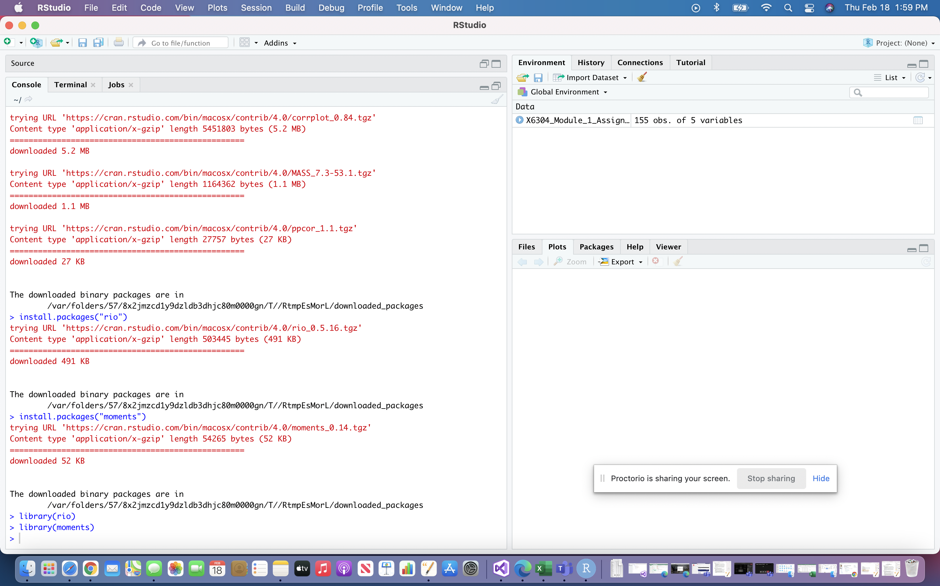

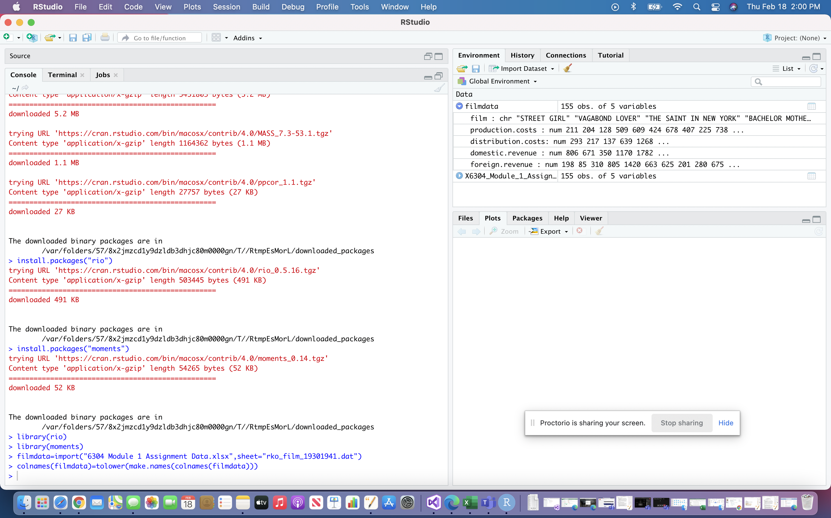

Question2 :

# Random Sample from Data

set.seed(62067273)

my.sample.data=filmdata[sample(1:nrow(filmdata),45),]

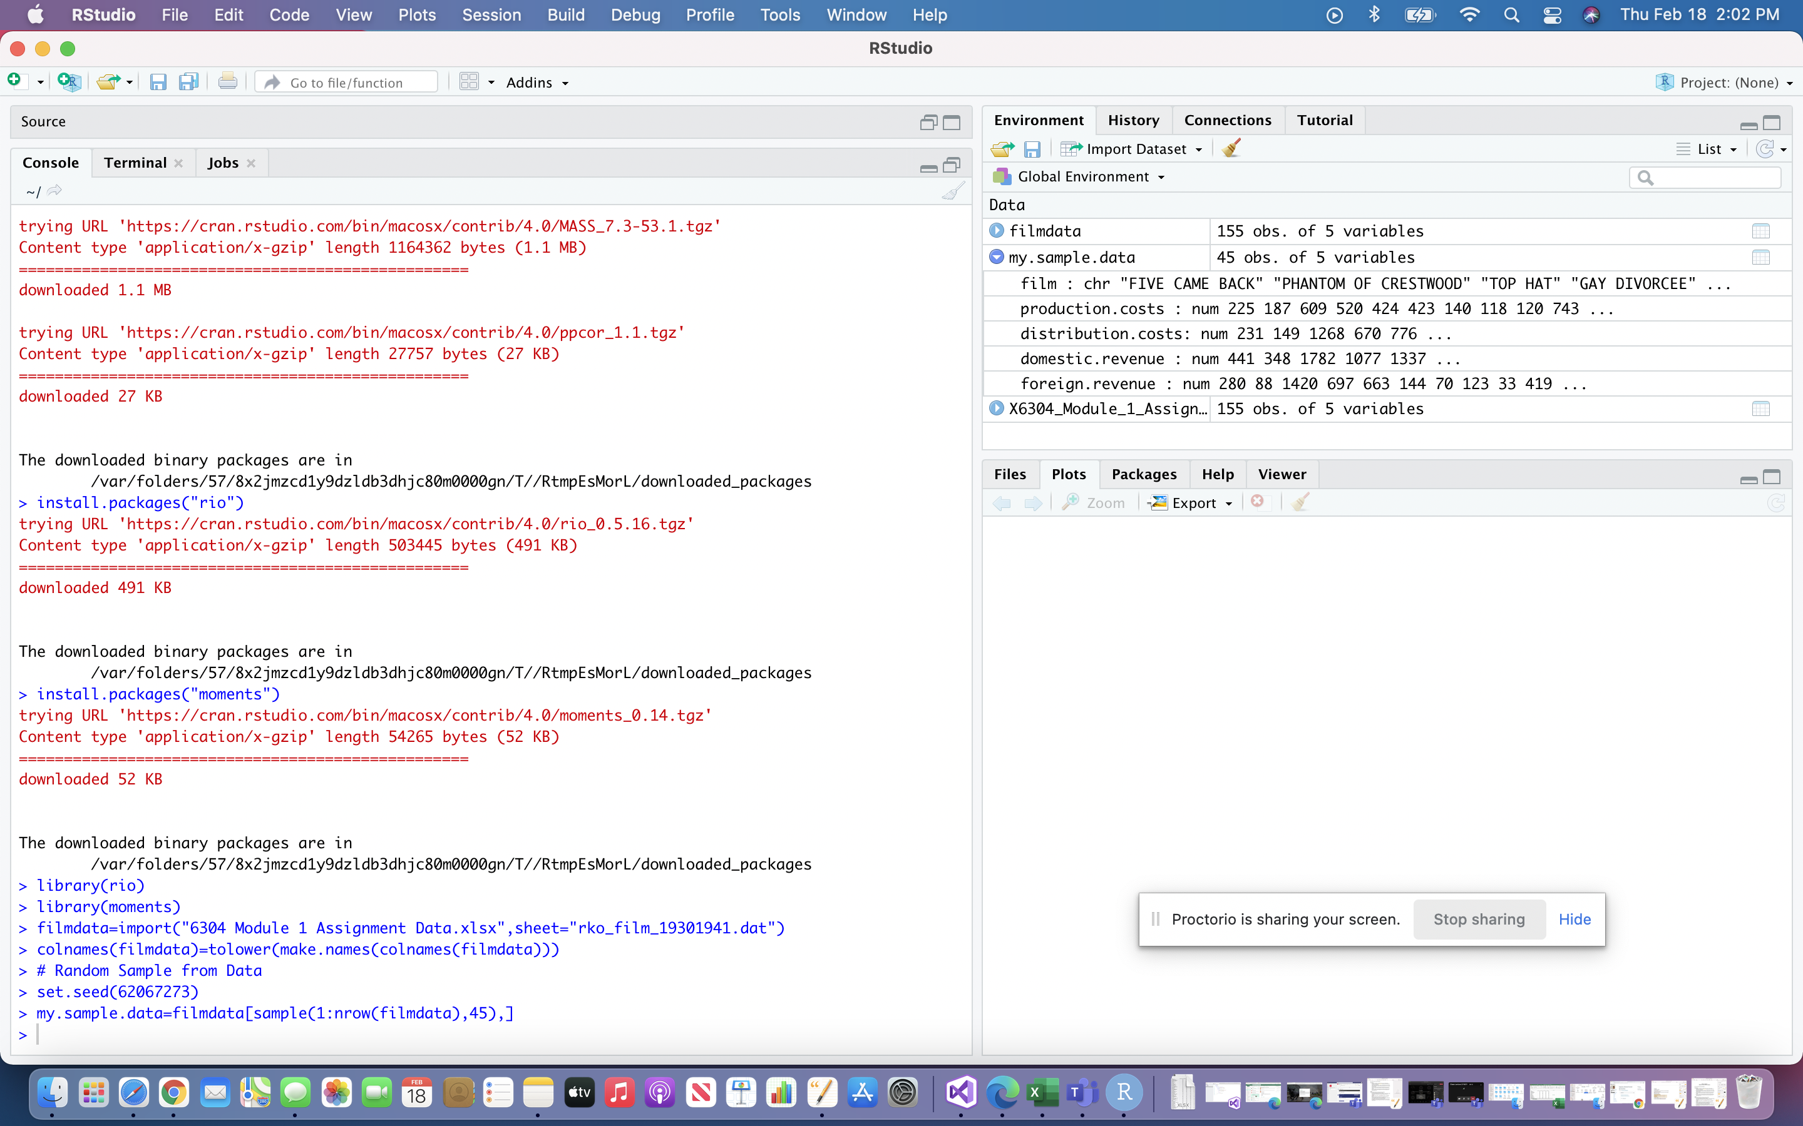

Question 3:

my.sample.data["total.revenue"] = my.sample.data$foreign.revenue + my.sample.data$domestic.revenue

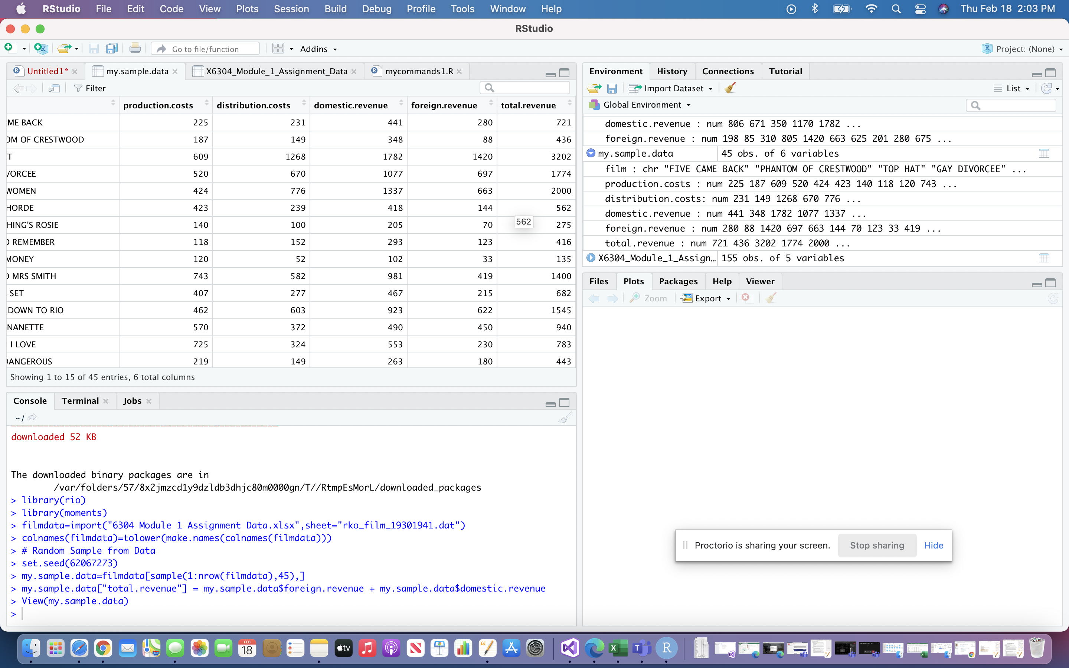

Question 4:

my.sample.data["total.profit"] = my.sample.data$total.revenue - my.sample.data$production.costs - my.sample.data$distribution.costs

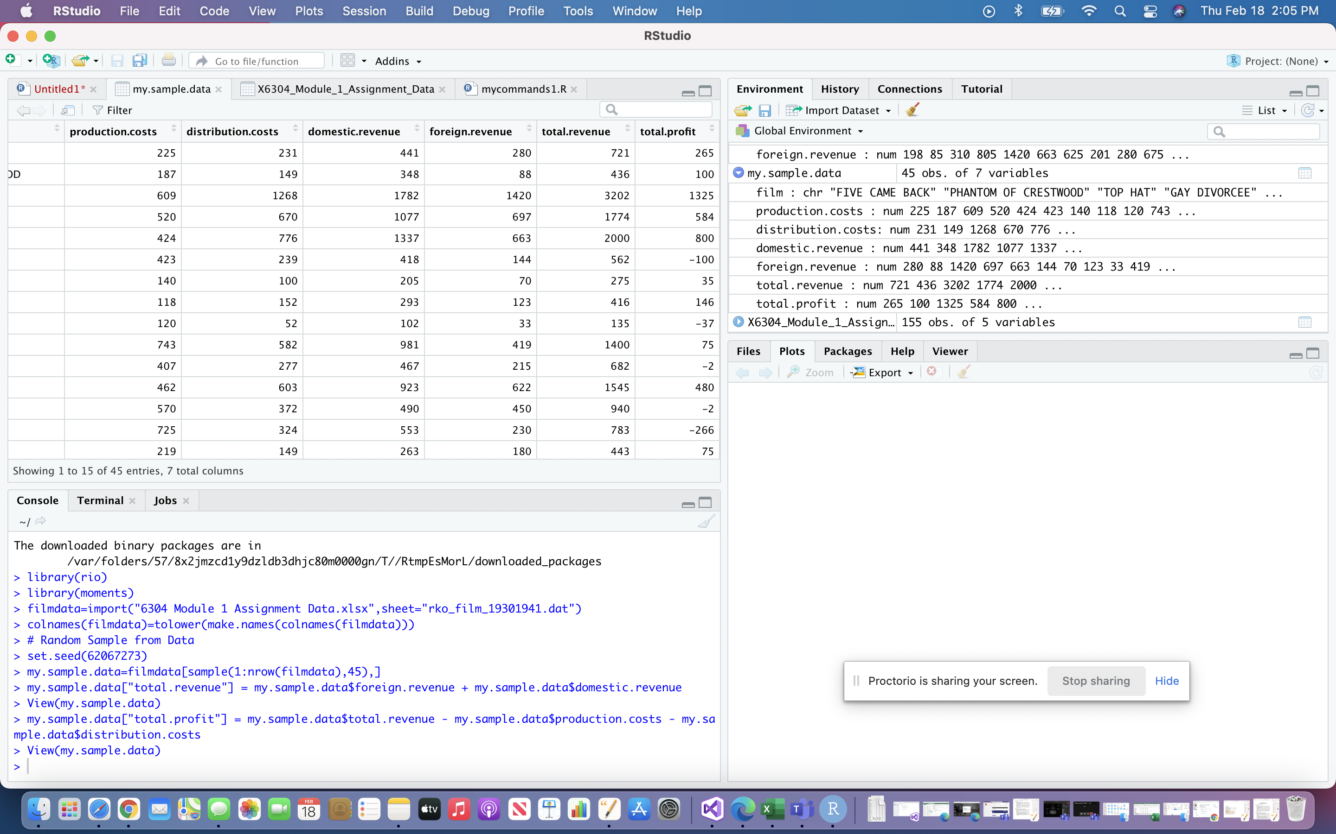

Question 5:

# Analysis part 1

str(my.sample.data$total.revenue)

mean(my.sample.data$total.profit)

median(my.sample.data$total.profit)

sd(my.sample.data$total.profit)

skewness(my.sample.data$total.profit)

kurtosis(my.sample.data$total.profit)

Based on the observations of mean, median and standard deviation the skewness value is 1.18 and the kurtosis value is 4.65. So, it is not symmetric right skewed graph.

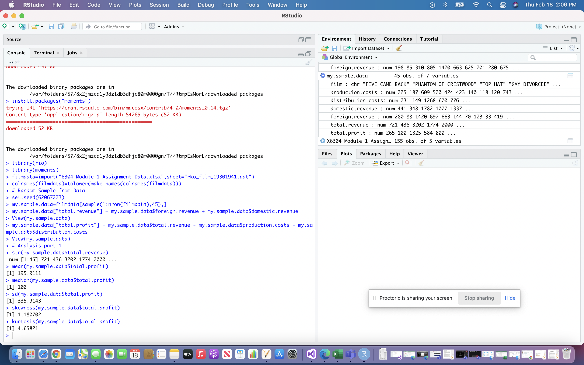

Question 6 :

#creating boxplot

boxplot(my.sample.data$total.profit,col="green",main="Boxplot for the profit for RKO studios")

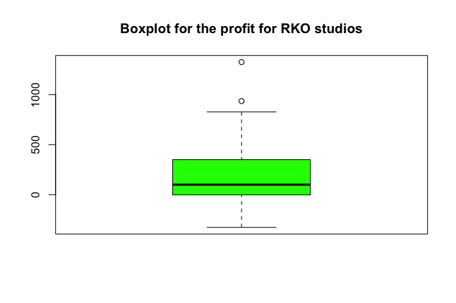

Question 7:

#creating quantiles

quantile(my.sample.data$domestic.revenue,probs=seq(0,1,.10))

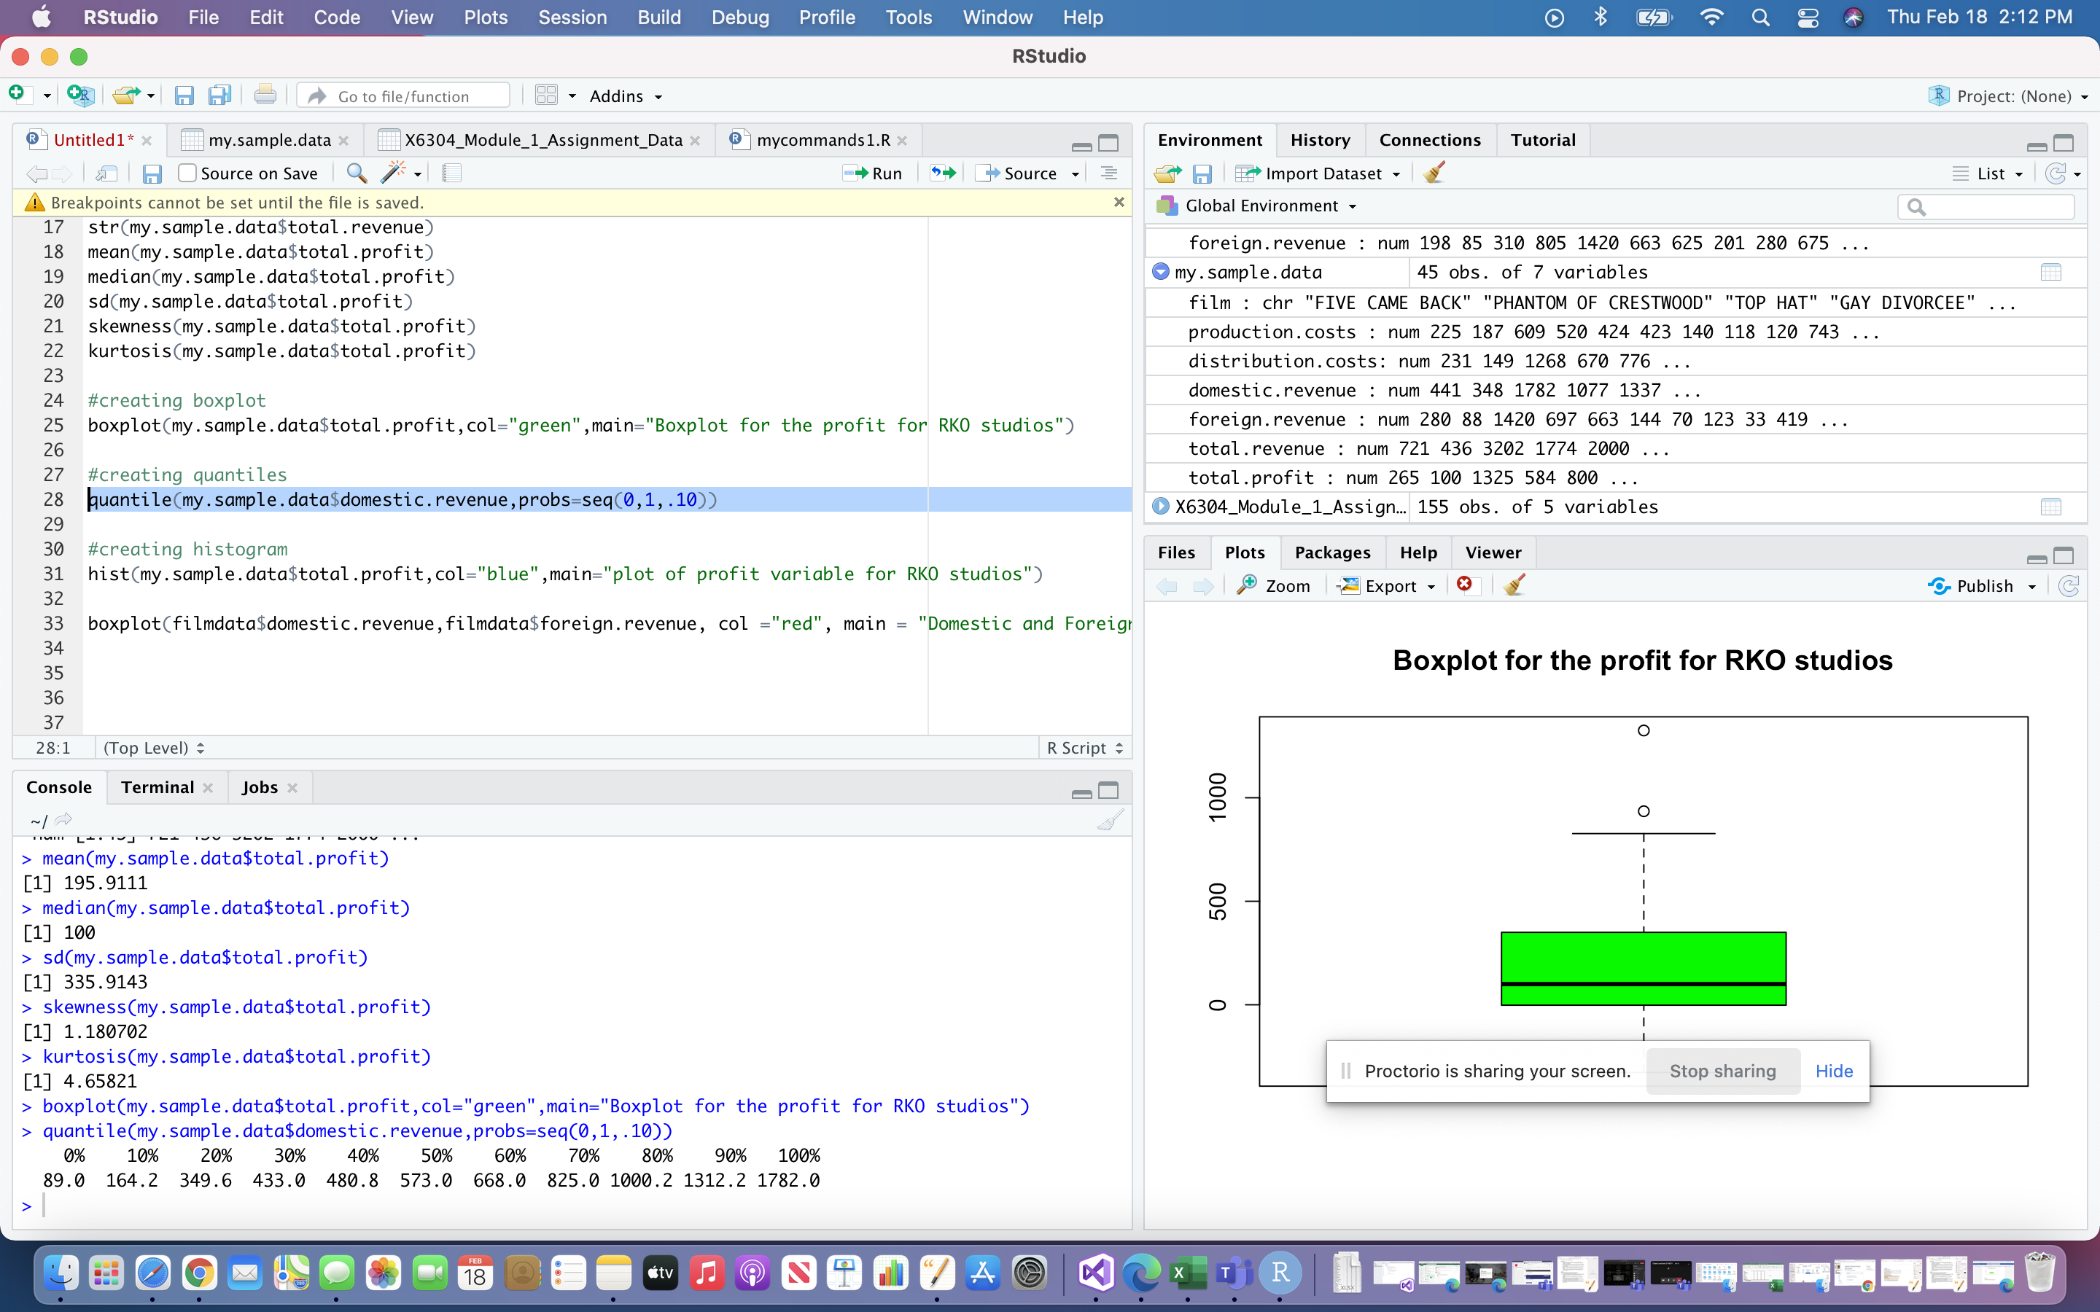

Question 8:

#creating histogram

hist(my.sample.data$total.profit,col="blue",main="plot of profit variable for RKO studios")

From the above plot we can tell that the RKO studios are profitable.

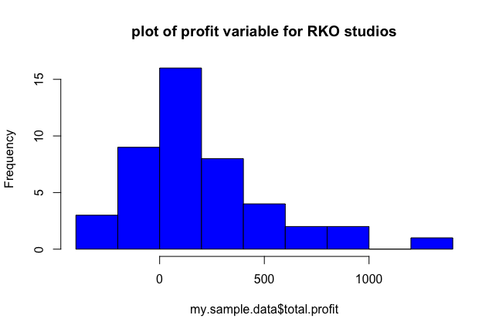

Question 9:

boxplot(filmdata$domestic.revenue,filmdata$foreign.revenue, col ="red", main = "Domestic and Foreign revenue", names= c("Domestic","Foreign"))

